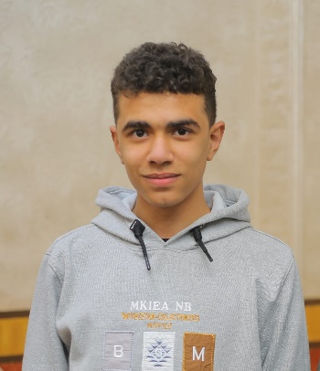**Adresse de courrier avec un remplissage uniCombiné avec un remplissage uniMaison avec un remplissage uni**

**Career Objective**

A university student specializing in Information Technology, aiming to achieve academic excellence by obtaining an honors degree. I aspire to become a teaching assistant at the university and aim to develop innovative technical projects that benefit humanity, particularly in programming and application development. I also seek to travel abroad to further enhance my skills and achieve my professional dreams.

**6/12/2006**

**Ahmed shawky**

Mohamed Shaheen

dargil alshuhada munawfia

01091422083

**Additional Activities**

**-** Exercising

- Supporting Favorite Football Clubs

**Languages**

- English: Good

- Italian: Beginner

**Hobbies and Interests**

-Technical Drawing

- Construction Engineering

- Programming

- Research in Technology

- Watching Football

Ahmedshawky10001@gmail.com

**Education**

**- Delta Technology University (DTU)**

Faculty: Industry and Energy Technology

Major: Information Technology (IT)

Year: First Year

Start Date: October 2024

**- Industrial Diploma**

School: Industrial Secondary School for Boys

Major: Electrical Studies

Graduation Date: July 2024

**Academic and Personal Projects**

**- IoT Project using Arduino:**

Implemented an academic project involving the use of Arduino to create a smart system based on IoT technologies.

**Additional Courses and Certifications**

-Basics of Electricity Course Level: Very Good

- Python Programming Course Level: Excellent

- English Course Level: Good

- C Programming Course Level: Very Good

- Microsoft Office Course (Word, Excel) Level: Very Good

**Work Experience**

**- Worked at a Construction Site:**

Gained practical experience in the field of construction and electrical engineering

**Skills**

**- Technical Skills:**

- Python Programming

- C Programming

- Microsoft Office (Word, Excel)

- Design

- Reading and Understanding Electrical Diagrams and Technical Symbols

- Basics of IoT using Arduino

**- Personal Skills:**

- Teamwork

- Ability to Work Under Pressure

- Time Management

- Motivating Others

- Prioritization

- Respectful Communication

**Additional Information**

Specialized in the field of electricity and electronics, with prior experience in construction engineering**.**